Paper: Multivariate Analysis

Topic: INTERNET USAGE

Group no: 6

Group Members:

02-Simeen Pawaskar
07- Aishwarya Borkar
08- Neha Chavhan
12- Sanchita Dabre
35- Sonali Patil
49- Madhura Jejurkar
50- Karthik Murthy

Introduction:

Internet has grown rapidly over the years. Today because of internet it is possible to access any information, communicate with anyone in the world. Using factor analysis and considering internet usage and its factors we will try to further simplify it.

Methodology:

The data was collected through survey of organized questionnaire i.e. Google form. It is based on 15 variables and the questions were related to internet, like factors affected due to internet usage. For analysis, factor analysis was conducted along with varimax method with the use of SPSS software

OBJECTIVE:
The survey form sought information on demographic data, availability of the Internet at home and school, how long students had used the Internet, with what frequency they used the Internet, what purpose they used it for, what sites were visited, impact of the Internet on student life, their attitudes about web based lecture notes, electronic discussion panel and web based education.

SAMPLE SIZE:
A total 203 students were responded the questionnaire. In which 104 respondents are female and 99 are males.

SAMPLING METHOD:
Non-probability sampling approaches for an online survey include:
•Convenience sampling,
•Voluntary response sampling and
•Snowball sampling.

SCALE:
For level of agreement:
1=Strongly agree, 2 =Agree, 3 =Neutral, 4 =Disagree, 5=Strongly disagree

GRAPHICAL REPRESENTATION:
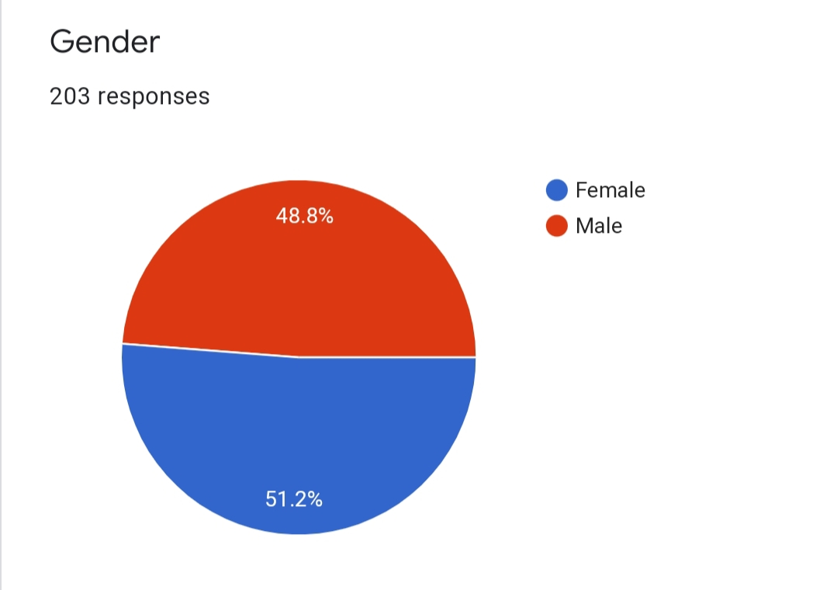

•Our sample of 203 includes, 99 males and 104 females that is sample is divided with respect to sex of a person.
•48.8% of males and 51.2% of females.

SOCIAL MEDIA:
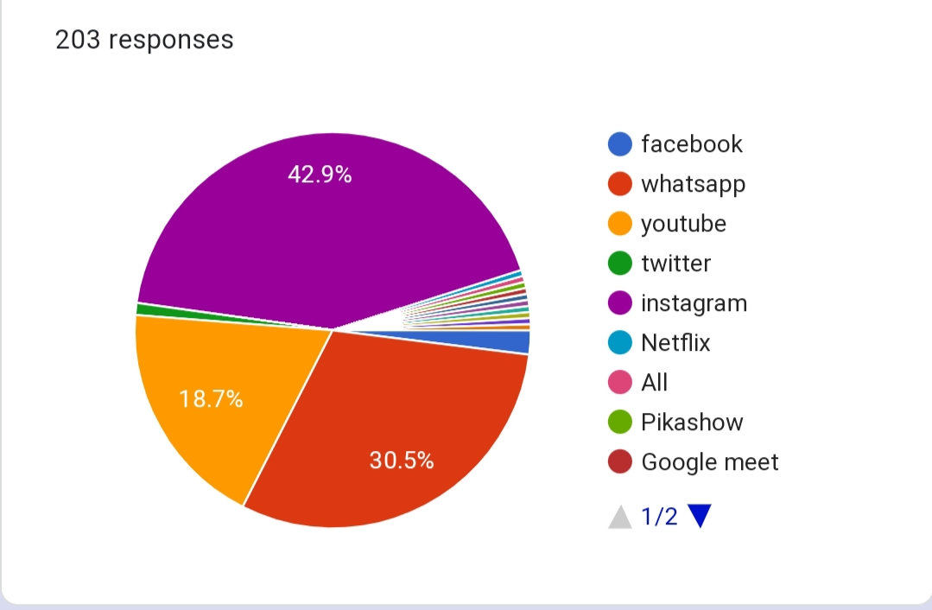

We observed that students spend more time on Instagram i.e 42.9% then on WhatsApp or on any other app.

FACTOR ANALYSIS:
Factor analysis is a method for analyzing data that allows research to identify the main factors or clusters that explain the relationship among the observed variables .

We use the following statistics in factor analysis:

• Correlation Matrix: A correlation (covariance) matrix is symmetric matrix showing the simple correlations, (covariance) between all possible pairs of variables included in the analysis.

• Communality: The portion of the variables of the ith variable contributed by the m common factors is called the Communality.

• Eigen Values: The Eigen values represent the total variance explained by each factor.

 |  | Householdchores | Socialization | Physicalactivity | Overcomingbadmoods | Loseofsleep | Onlinegames
Householdchores | Pearson Correlation | 1 | .141* | .341** | 0.101 | .184** | .158*
Householdchores | Sig. (2-tailed) |  | 0.045 | 0.000 | 0.153 | 0.009 | 0.025
Householdchores | N | 203 | 203 | 203 | 203 | 203 | 203
Socialization | Pearson Correlation | .141* | 1 | .325** | .168* | .264** | -0.015
Socialization | Sig. (2-tailed) | 0.045 |  | 0.000 | 0.016 | 0.000 | 0.829
Socialization | N | 203 | 203 | 203 | 203 | 203 | 203
Physicalactivity | Pearson Correlation | .341** | .325** | 1 | .173* | .392** | 0.065
Physicalactivity | Sig. (2-tailed) | 0.000 | 0.000 |  | 0.013 | 0.000 | 0.359
Physicalactivity | N | 203 | 203 | 203 | 203 | 203 | 203
Overcomingbadmoods | Pearson Correlation | 0.101 | .168* | .173* | 1 | 0.071 | .216**
Overcomingbadmoods | Sig. (2-tailed) | 0.153 | 0.016 | 0.013 |  | 0.311 | 0.002
Overcomingbadmoods | N | 203 | 203 | 203 | 203 | 203 | 203
Loseofsleep | Pearson Correlation | .184** | .264** | .392** | 0.071 | 1 | 0.098
Loseofsleep | Sig. (2-tailed) | 0.009 | 0.000 | 0.000 | 0.311 |  | 0.165
Loseofsleep | N | 203 | 203 | 203 | 203 | 203 | 203
Onlinegames | Pearson Correlation | .158* | -0.015 | 0.065 | .216** | 0.098 | 1
Onlinegames | Sig. (2-tailed) | 0.025 | 0.829 | 0.359 | 0.002 | 0.165
Onlinegames | N | 203 | 203 | 203 | 203 | 203 | 203

Carryingmobiledevice | Pearson Correlation | .275** | 0.108 | .288** | 0.135 | .344** | .158*
Carryingmobiledevice | Sig. (2-tailed) | 0.000 | 0.125 | 0.000 | 0.055 | 0.000 | 0.025
Carryingmobiledevice | N | 203 | 203 | 203 | 203 | 203 | 203
Restricted Place | Pearson Correlation | .326** | 0.078 | .272** | 0.112 | .199** | .206**
Restricted Place | Sig. (2-tailed) | 0.000 | 0.266 | 0.000 | 0.112 | 0.004 | 0.003
Restricted Place | N | 203 | 203 | 203 | 203 | 203 | 203
Notification alert | Pearson Correlation | .264** | .169* | .325** | 0.100 | .271** | 0.022
Notification alert | Sig. (2-tailed) | 0.000 | 0.016 | 0.000 | 0.158 | 0.000 | 0.753
Notification alert | N | 203 | 203 | 203 | 203 | 203 | 203
Depression | Pearson Correlation | .308** | .234** | .269** | .165* | .267** | 0.038
Depression | Sig. (2-tailed) | 0.000 | 0.001 | 0.000 | 0.019 | 0.000 | 0.592
Depression | N | 203 | 203 | 203 | 203 | 203 | 203
FrequencyofInternetUsage | Pearson Correlation | .146* | .343** | .384** | .150* | .355** | 0.067
FrequencyofInternetUsage | Sig. (2-tailed) | 0.037 | 0.000 | 0.000 | 0.032 | 0.000 | 0.345
FrequencyofInternetUsage | N | 203 | 203 | 203 | 203 | 203 | 203
purchase digital product | Pearson Correlation | .232** | 0.014 | -0.026 | .164* | 0.109 | .160*
purchase digital product | Sig. (2-tailed) | 0.001 | 0.846 | 0.715 | 0.020 | 0.123 | 0.023
purchase digital product | N | 203 | 203 | 203 | 203 | 203 | 203
Grades and productivity | Pearson Correlation | .274** | .202** | .395** | .178* | .273** | .193**
Grades and productivity | Sig. (2-tailed) | 0.000 | 0.004 | 0.000 | 0.011 | 0.000 | 0.006
Grades and productivity | N | 203 | 203 | 203 | 203 | 203 | 203
Disturbeddailyschedule | Pearson Correlation | .277** | .265** | .450** | 0.122 | .453** | 0.115
Disturbeddailyschedule | Sig. (2-tailed) | 0.000 | 0.000 | 0.000 | 0.082 | 0.000 | 0.101
Disturbeddailyschedule | N | 203 | 203 | 203 | 203 | 203 | 203
Childrens  overallschedule | Pearson Correlation | -0.007 | .412** | .353** | .194** | .367** | 0.076
Childrens  overallschedule | Sig. (2-tailed) | 0.925 | 0.000 | 0.000 | 0.005 | 0.000 | 0.284
Childrens  overallschedule | N | 203 | 203 | 203 | 203 | 203 | 203

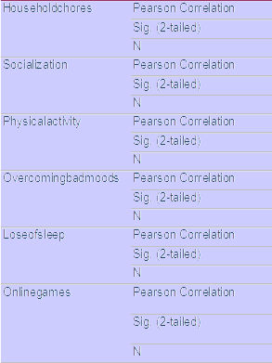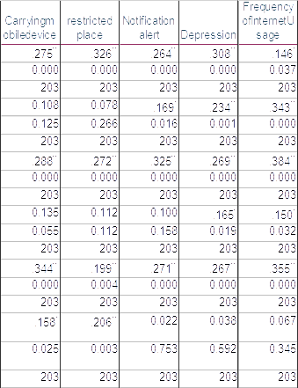

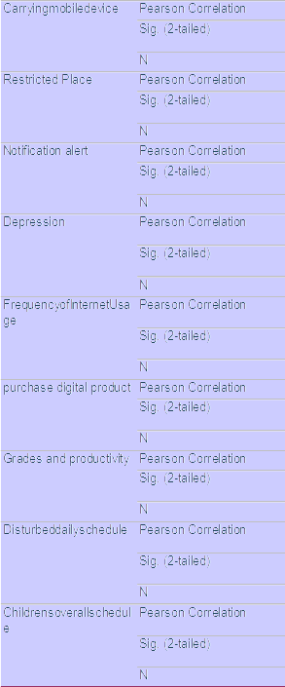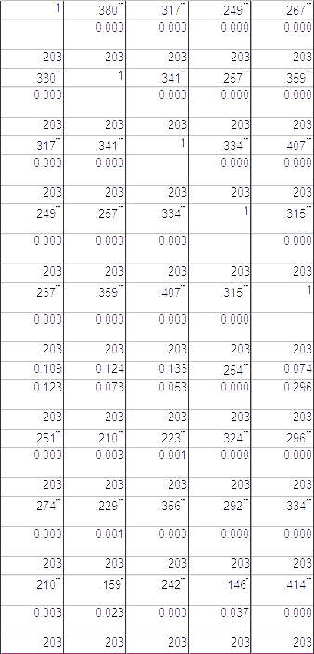

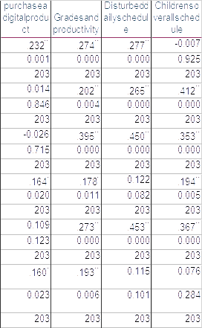

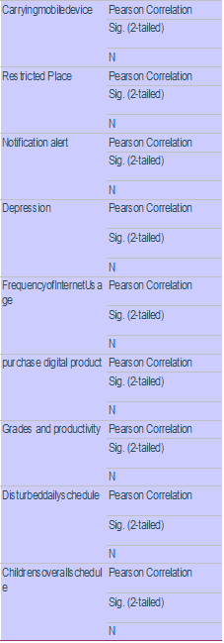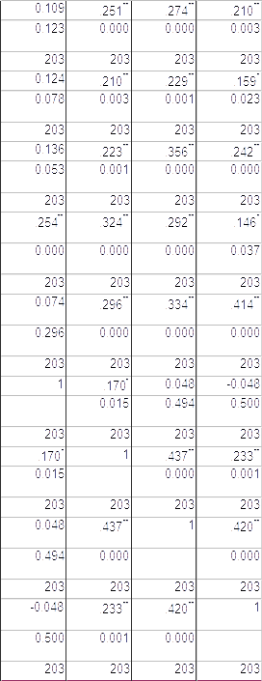

*Correlation is significant at 0.05 level(2-tailed)
**Correlation is significant at 0.01 level(2-tailed)

Statistics for testing the appropriateness of the factor analysis.

Kaiser-Mayer-Olkin(KMO) Measure:-

It is a statistic that indicates the proportion of variance in your variables that might be caused by underlying factors.
High values (close to 1.0) generally indicate that a factor analysis is useful for data.

Bartlett’s Test of Sphericity :-

Tests the hypothesis that your correlation matrix is an identity matrix.
Small values (less than 0.05) of the significance level indicate that a factor analysis is useful with your data.

Kaiser-Mayer-Olkin(KMO) Statistics:

KMO Criterion: 0.846.
The value of KMO statistics is 0.846. which is greater than 0.5, sample adequacy is met and we proceed with Factor Analysis as an appropriate technique of date reduction.

ϖ Bartlett’s test of Sphericity:

H0: Population correlation matrix is Identity matrix.
H1: Population correlation matrix is not an Identity matrix.

Appro. Chi-square value =668.511 , df=105 ,p-value < 0.05.
Since p-value is significant we reject H0 and conclude that assumption of multicollinearity is satisfied.
Hence we proceed with factor analysis using principal component analysis as an appropriate technique of data reduction.
Communalities
 | Initial | Extraction
Householdchores | 1.000 | .498
Socialization | 1.000 | .561
Physicalactivity | 1.000 | .503
Overcomingbadmoods | 1.000 | .572
Loseofsleep | 1.000 | .427
Onlinegames | 1.000 | .728
Carryingmobiledevice | 1.000 | .504
Accessedtheinternetwithyourmobiledeviceduringa | 1.000 | .565
Notificationalert | 1.000 | .479
Depression | 1.000 | .589
FrequencyofInternetUsage | 1.000 | .477
purchaseadigitalproduct | 1.000 | .624
Gradesandproductivity | 1.000 | .400
Disturbeddailyschedule | 1.000 | .502
Childrensoverallschedule | 1.000 | .657
Extraction Method: Principal Component Analysis.

